SEVEN STARS, SEVEN STORIES
Seven different souls, seven unique journeys, one unforgettable story.
Seven individuals. Seven different personalities. Seven different dreams. Yet, somehow, their paths crossed and created a story that millions of hearts would become a part of.
They are not just seven performers standing on a stage. They are seven artists who grew together, learned together, faced challenges together, and created music that travelled beyond languages and borders.
Each member has a story of his own, and each story adds a different colour to the beautiful universe of BTS.

1. RM – The Leader Who Teaches Us to Find Ourselves
Real Name: Kim Namjoon
Birthday: September 12, 1994
Position: Leader, Main Rapper
Kim Namjoon, known as RM, is the leader who brings seven different personalities together. His journey is a reflection of intelligence, curiosity, creativity, and continuous self-discovery.
Through his thoughtful lyrics and meaningful words, RM has encouraged millions of people to question the world, understand their emotions, and most importantly, learn to love themselves. His love for literature, art, and nature reveals a mind that is always exploring and discovering something new.
But being a leader is not simply about standing in front. It is also about growing alongside others, accepting imperfections, and finding strength in unity. Namjoon has shown us that leadership can be gentle, thoughtful, and full of understanding.
To ARMY, he is more than the leader of BTS. He is a reminder that we do not need to have everything figured out to move forward. It is okay to make mistakes, change our minds, and discover ourselves along the way.
His story reminds us that growing up means learning to understand ourselves, not becoming perfect.
2. JIN – The Beautiful Light Behind Every Smile
Real Name: Kim Seokjin
Birthday: December 4, 1992
Position: Vocalist, Visual
Kim Seokjin, lovingly known as Jin(Our World Wide Handsome), is one of the brightest personalities in BTS. With his playful humour, unforgettable jokes, and warm personality, he has a special way of bringing smiles to people around him.
However, behind all the laughter is an artist whose dedication and love for music deserve just as much appreciation. From his beautiful vocals to his emotional solo songs, Jin has shown different sides of himself through music.
His journey reminds us that we can be strong without always appearing serious, and we can bring happiness to others while continuing to work on our own dreams.
For ARMY, Jin represents comfort, laughter, confidence, and warmth. His presence reminds us that sometimes the smallest moments of happiness become our most precious memories.
His story reminds us that a little kindness, a genuine smile, and the ability to laugh can brighten someone's entire day.
3. SUGA – The Voice That Turns Feelings into Music
Real Name: Min Yoongi
Birthday: March 9, 1993
Position: Lead Rapper
Min Yoongi, known as SUGA and also as Agust D, is an artist whose music speaks with remarkable honesty. His journey is built on determination, hard work, and an unbreakable passion for music.
As a rapper, songwriter, and producer, he has created music that explores dreams, ambitions, personal experiences, and the complicated emotions of being human. His lyrics often give words to feelings that people struggle to express.
His personality may seem quiet at times, but his artistic expression is powerful. He has shown that being honest about our emotions is not a weakness. It takes courage to accept our experiences and turn them into something meaningful.
For many ARMYs, his music feels like a reminder that their emotions are valid and that difficult days do not define their entire journey.
His story reminds us that even our most complicated feelings can become something beautiful when we find the courage to express them.
4. j-hope – The Sunshine That Carries Hope
Real Name: Jung Hoseok
Birthday: February 18, 1994
Position: Main Dancer, Sub- Rapper, Sub- Vocalist
Jung Hoseok, known as j-hope, brings an extraordinary combination of energy, creativity, and passion to BTS. His dancing, stage presence, and vibrant personality make him an unforgettable performer.
Often associated with sunshine and positivity, j-hope represents the beautiful idea of hope. But his journey also shows that positivity does not mean life is always easy. Behind every powerful performance is dedication, discipline, and countless hours of hard work.
Through his solo music, he has explored his own artistic identity and demonstrated his versatility as a musician. He continues to inspire people to believe in their abilities and pursue their dreams with confidence.
To ARMY, j-hope is a symbol of encouragement. He reminds us that even when the road feels uncertain, we can find a reason to keep moving forward.
His story reminds us that hope is not about having a perfect life; it is about finding the strength to keep going.
5. JIMIN – The Heart That Speaks Through Dance and Music
Real Name: Park Jimin (ANGELIC)
Birthday: October 13, 1995
Position: LeadVocalist, Main Dancer
Park Jimin is an artist whose performances beautifully combine grace, emotion, and dedication. His expressive dancing and distinctive vocal colour make him one of the most recognisable performers in BTS.
There is something special about the way Jimin expresses himself through music. Whether on stage or through his solo work, he has a remarkable ability to communicate emotions without needing too many words.
His journey reflects the importance of practice, patience, and believing in oneself. Behind his graceful performances is an artist who continues to challenge himself and grow.
For ARMY, Jimin represents warmth, emotional expression, and the courage to show our sensitive side. He reminds us that being gentle does not make us weak and that our feelings deserve to be understood.
His story reminds us that the heart has its own language, and sometimes music is the most beautiful way to speak it.
6. V – The Soul That Finds Beauty in Being Different
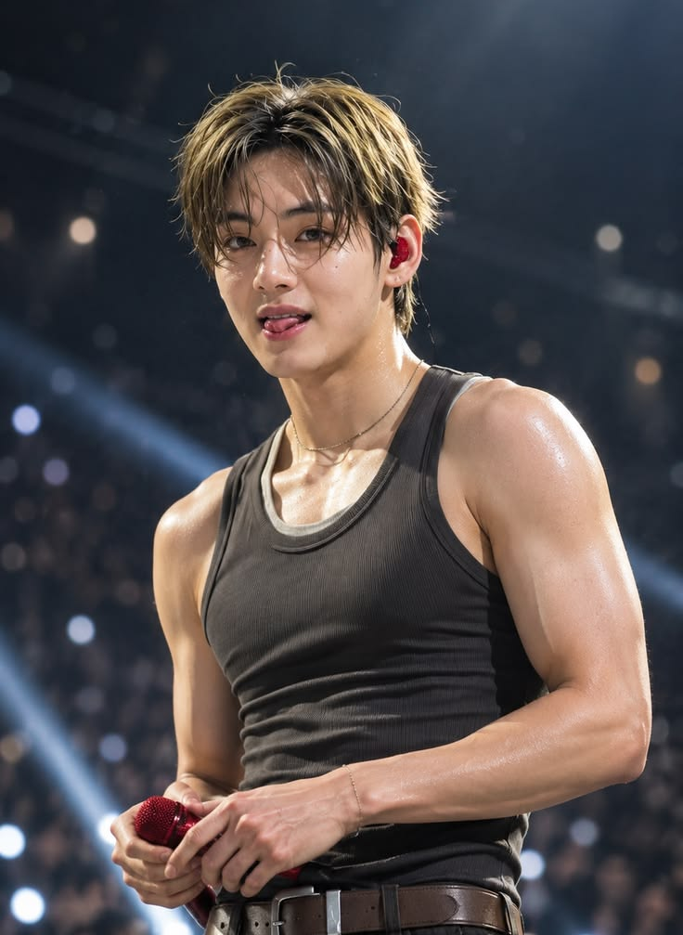
Real Name: Kim Taehyung
Birthday: December 30, 1995
Position: Vocalist, Visual, Lead Dancer
Kim Taehyung, known as V, is admired for his deep, distinctive voice and wonderfully individual artistic personality. His approach to music often carries a soulful quality, with influences that reflect his love for different musical styles.
But Taehyung's creativity extends beyond music. His interests in photography, art, fashion, and visual storytelling reveal an imaginative mind that sees beauty in unexpected places.
He has never needed to fit into a single definition of an artist. Instead, he continues to explore his individuality and express himself in his own way.
To ARMY, V represents the beauty of being different. His journey reminds us that we do not have to become someone else to be appreciated. We can create our own path, follow our interests, and embrace the things that make us unique.
His story reminds us that being different is not something to hide; it is something that makes our story special.
7. JUNGKOOK – The Golden Maknae Who Never Stops Growing
Real Name: Jeon Jungkook
Birthday: September 1, 1997
Position: Main Vocalist, Lead Dancer, Sub-Rapper, Center, Golden Maknae
Jeon Jungkook, the youngest member of BTS, is famously known as the Golden Maknae because of his remarkable abilities in singing, dancing, performing, and exploring different creative fields.
From joining BTS at a young age to becoming a global artist, his journey reflects years of dedication, discipline, and personal growth. Watching his development as a performer has been an unforgettable part of BTS's story.
His powerful vocals, energetic performances, and willingness to challenge himself have made him an important part of the group's musical identity. Through his solo music, he has also explored his own artistic direction.
For ARMY, Jungkook's journey represents the beauty of growing up while holding on to our dreams. He reminds us that we do not need to be perfect from the beginning. What matters is the willingness to learn, improve, and keep trying.
His story reminds us that our dreams can grow with us, and there is always something new waiting to be discovered.

SEVEN MEMBERS, ONE UNBREAKABLE BOND
Seven birthdays. Seven personalities. Seven individual journeys.
Namjoon, who reminds us to understand ourselves.
Seokjin, who teaches us the beauty of laughter.
Yoongi, who gives emotions a voice.
Hoseok, who carries hope wherever he goes.
Jimin, who expresses the language of the heart.
Taehyung, who celebrates individuality.
Jungkook, who reminds us to keep growing.
They began their journey as seven young individuals with dreams, uncertainties, and hopes for the future. Along the way, they became a team, a family, and a musical force that connected people across the world.
And somewhere between their songs, performances, laughter, and stories, millions of people found a reason to smile, a little comfort on difficult days, and the courage to believe in themselves.
Perhaps that is what makes BTS so special. Not because they are all the same, but because they are different in so many beautiful ways.
Seven stars may shine differently, but together they create a constellation called BTS.
Seven members. One name. One family. One beautiful universe — Bangtan Sonyeondan. 

